Setting up tmpnb Server for Class of 55 Students

1. Login to AWS on through the following URL.  
   <https://aws.amazon.com/>
2. Click to “Sign In To The Console“ to enter the AWS Portal and create credentials if you have not done so already.  
   
3. Click on EC2. We’ll be using EC2 to host our tmpnb server. Make sure the region you have selected is in Singapore.

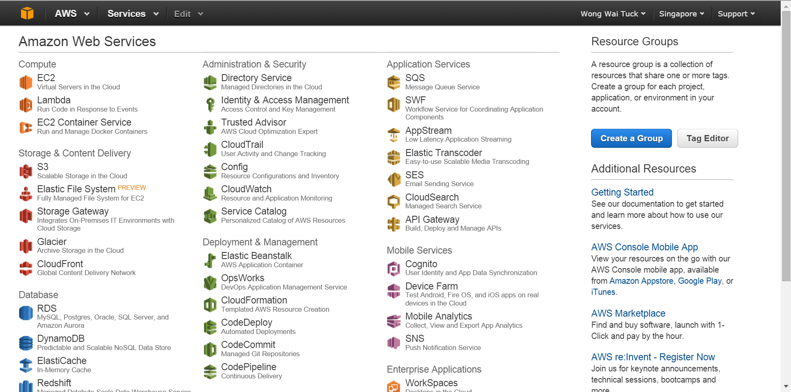

1. You will be greeted with the default managing page for EC2. Click the “Launch Instance” button to launch an instance.  
   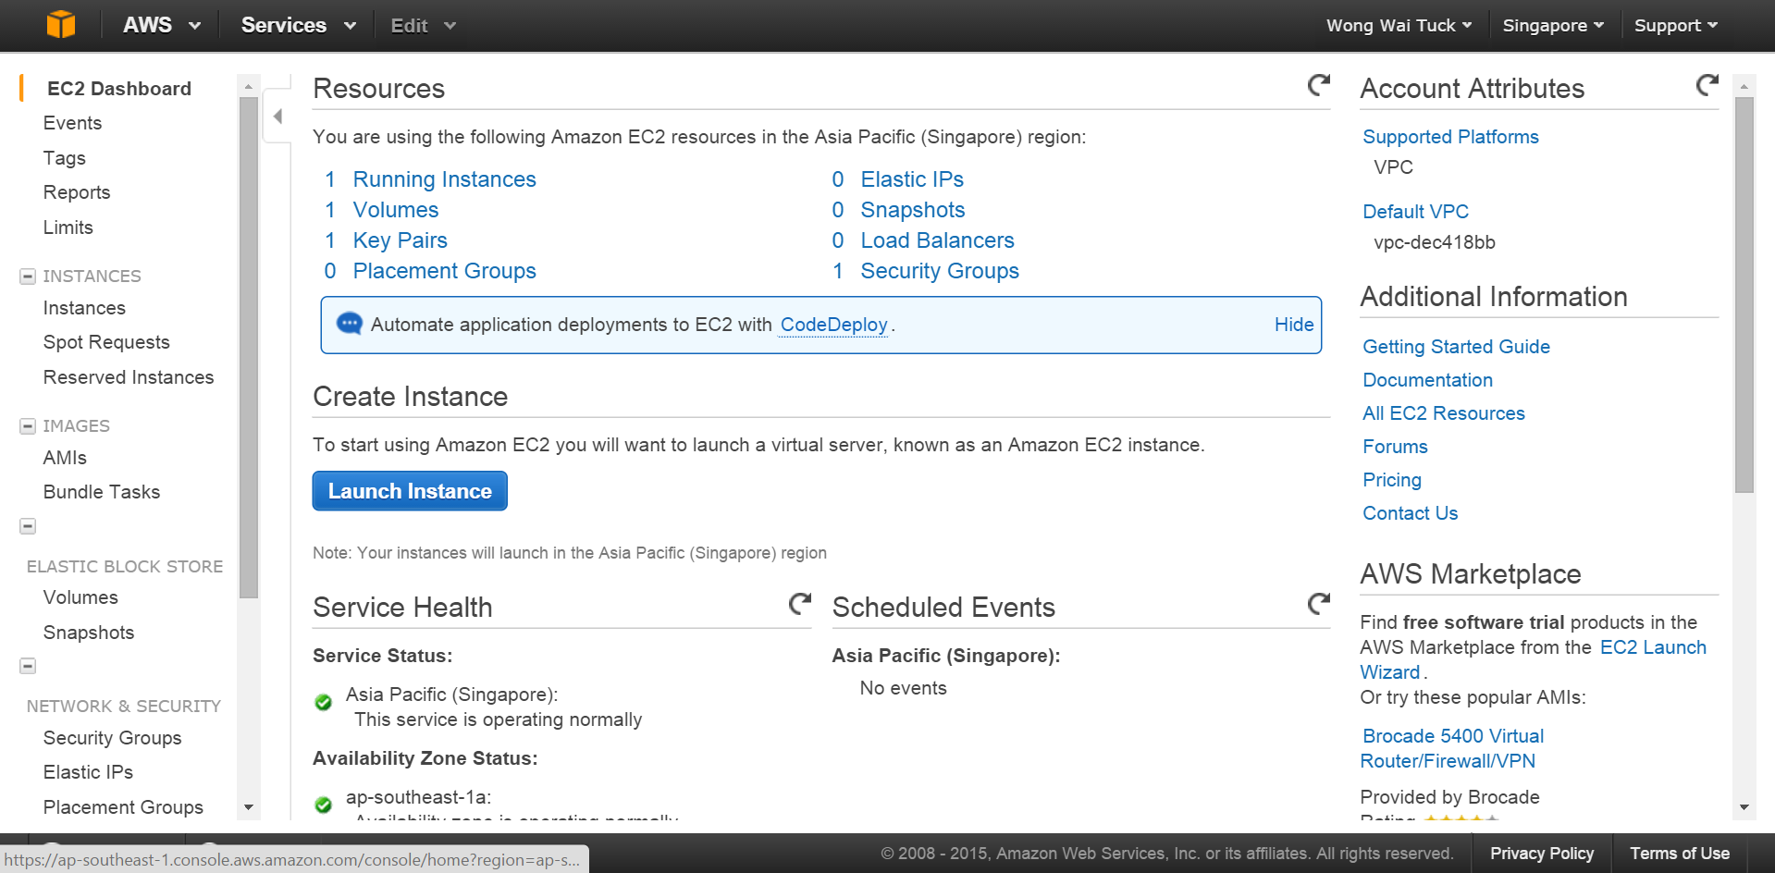
2. Select Amazon AMI   
   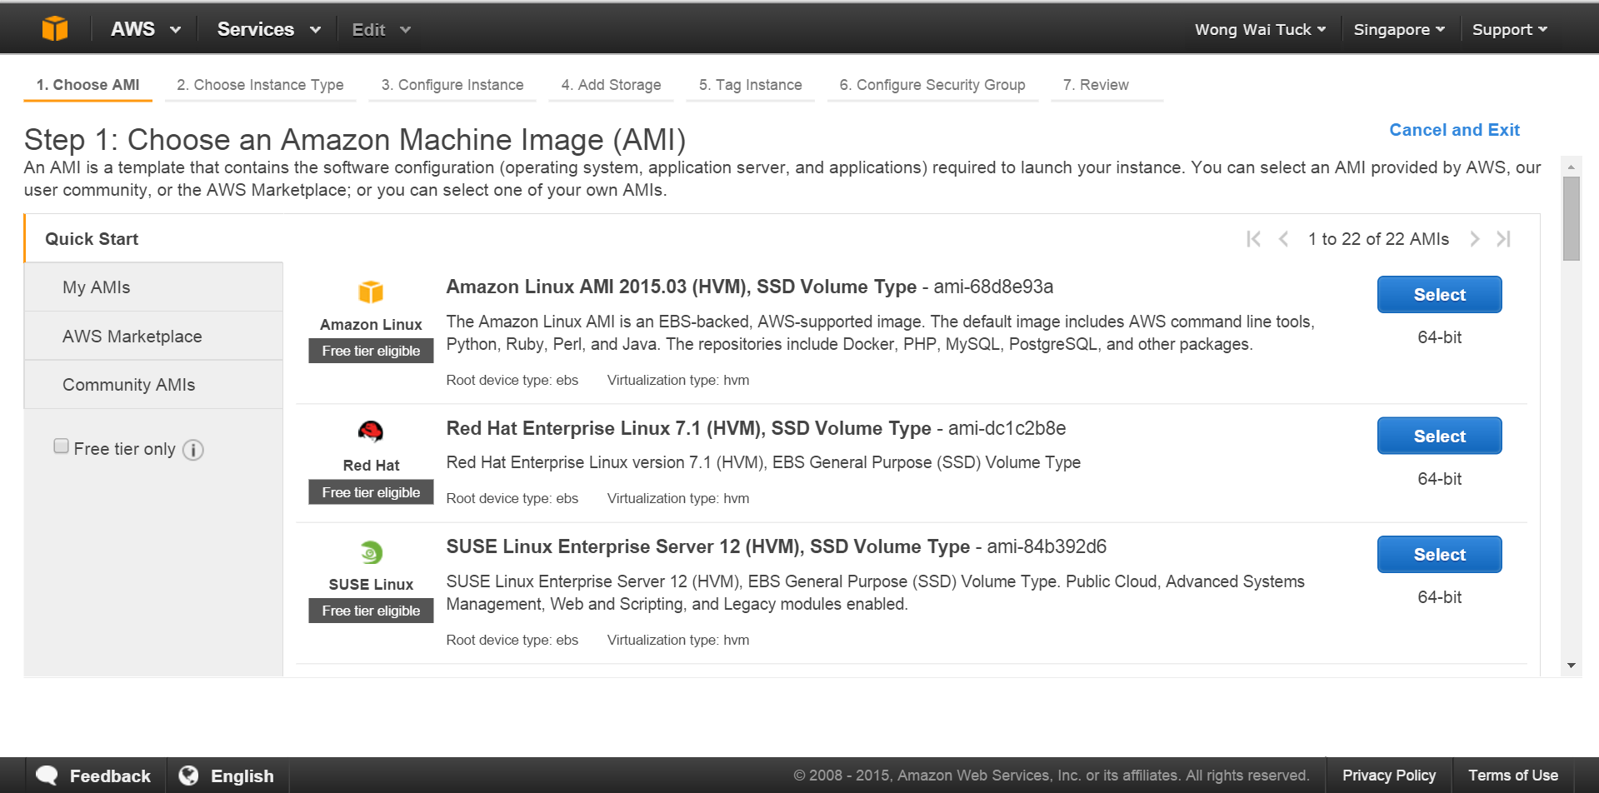
3. Select an instance type that is suitable, then click “Next: Configure Instance Details”.  
   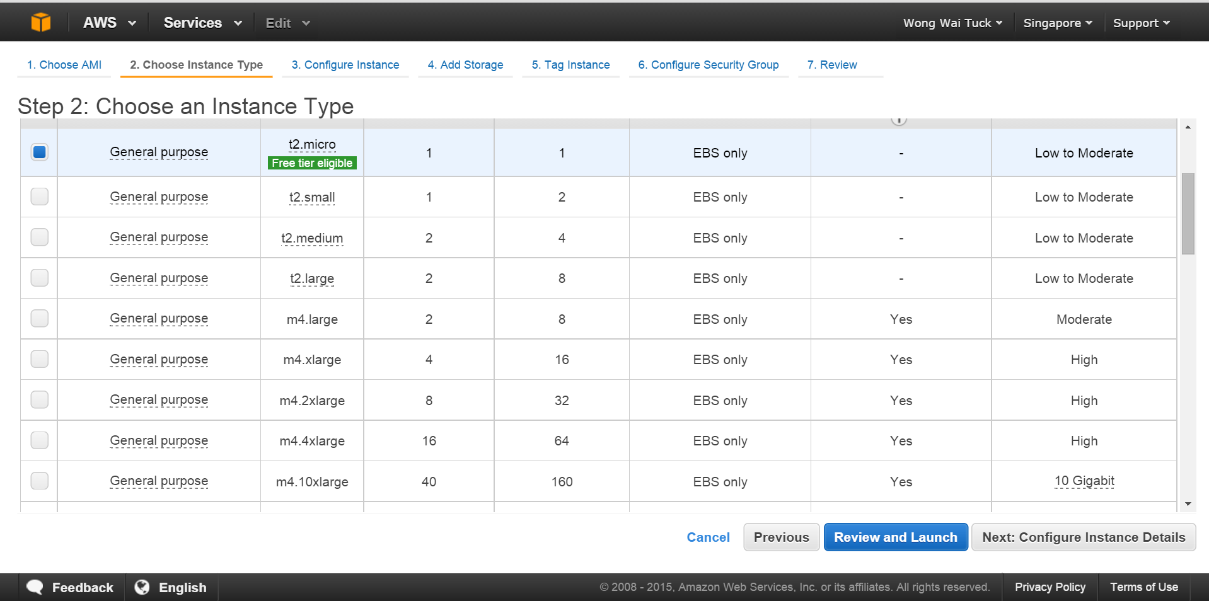
4. Select “Next: Add Storage”  
   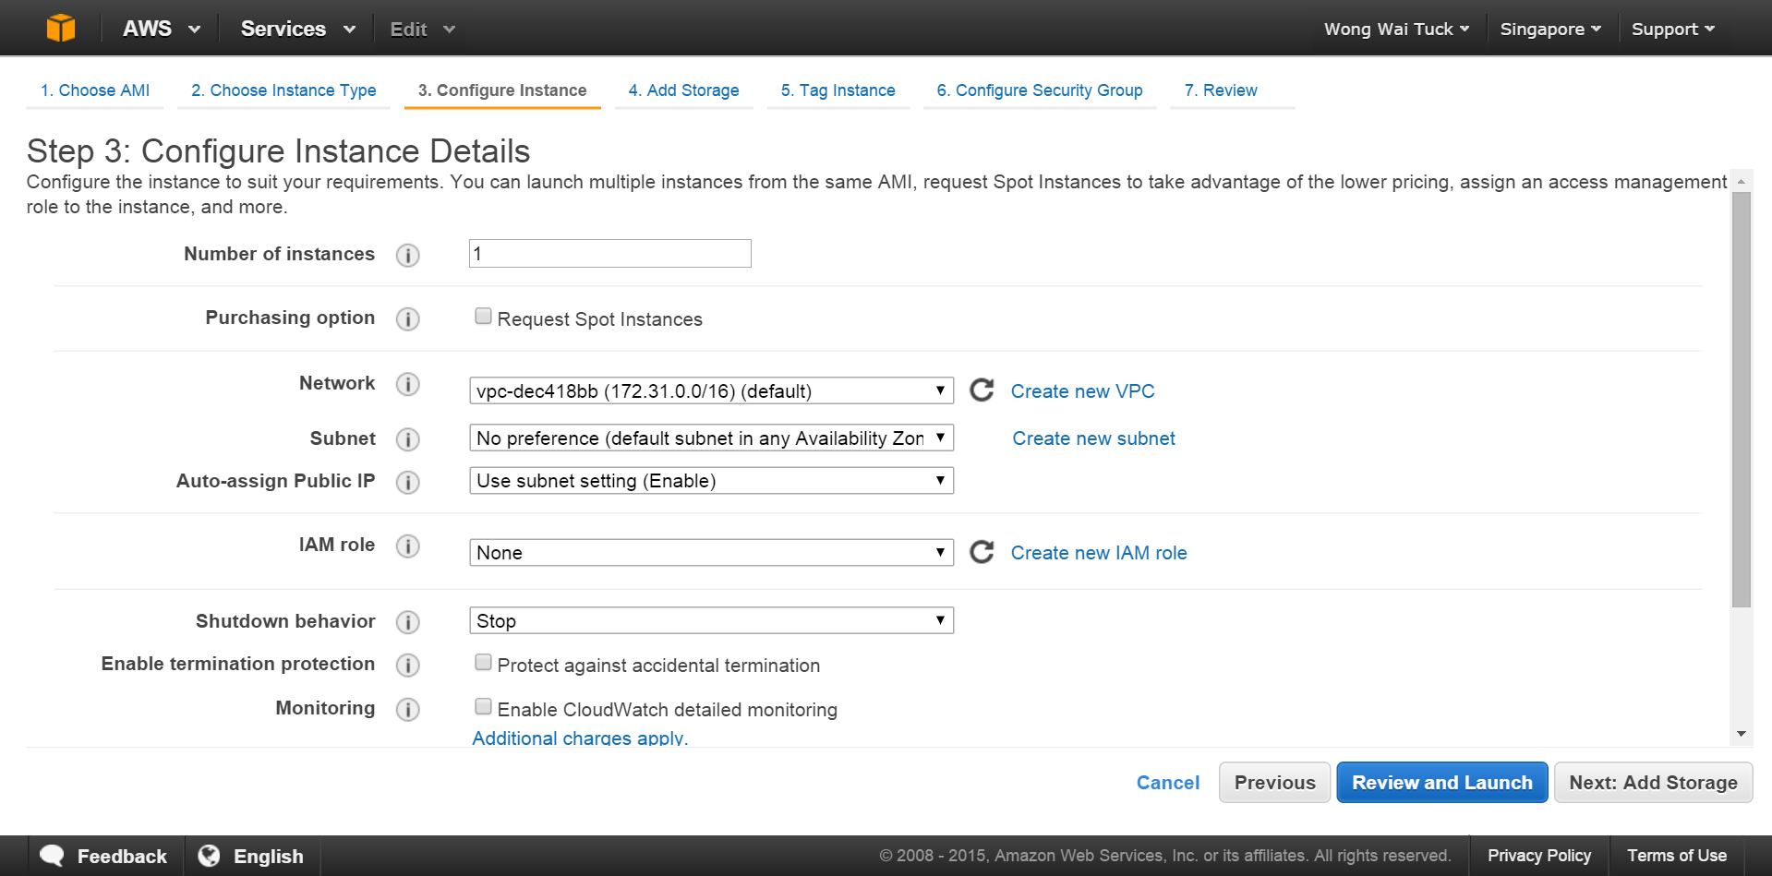
5. Change the size to a larger number (say 20GB), and press “Next: Tag Instance”.   
   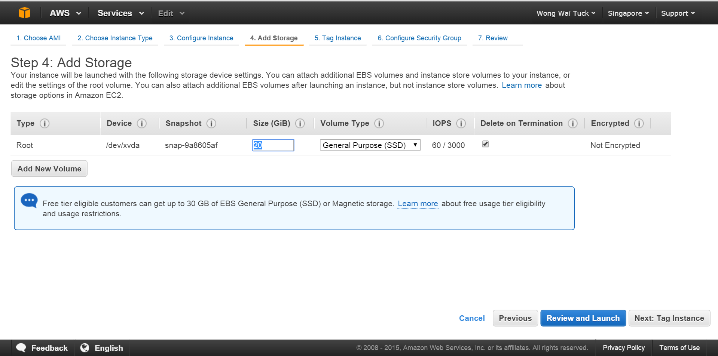
6. Press “Next: Configure Security Group”  
   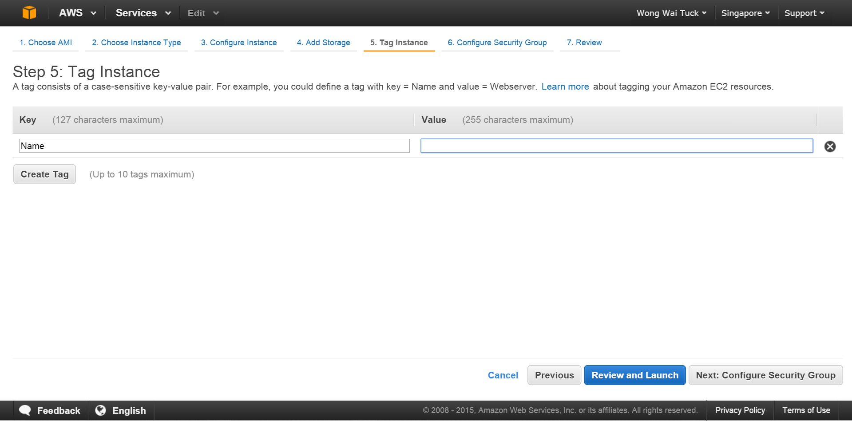
7. Make sure that “Create a new security group” is selected add the following Custom TCP Rules as below and press “Review and Launch”.  
   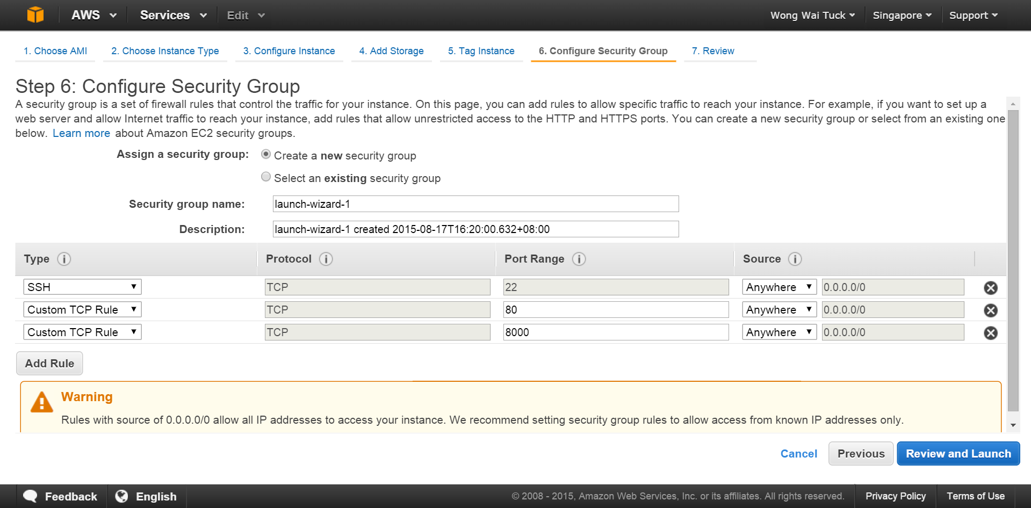
8. Review and launch your instance!  
   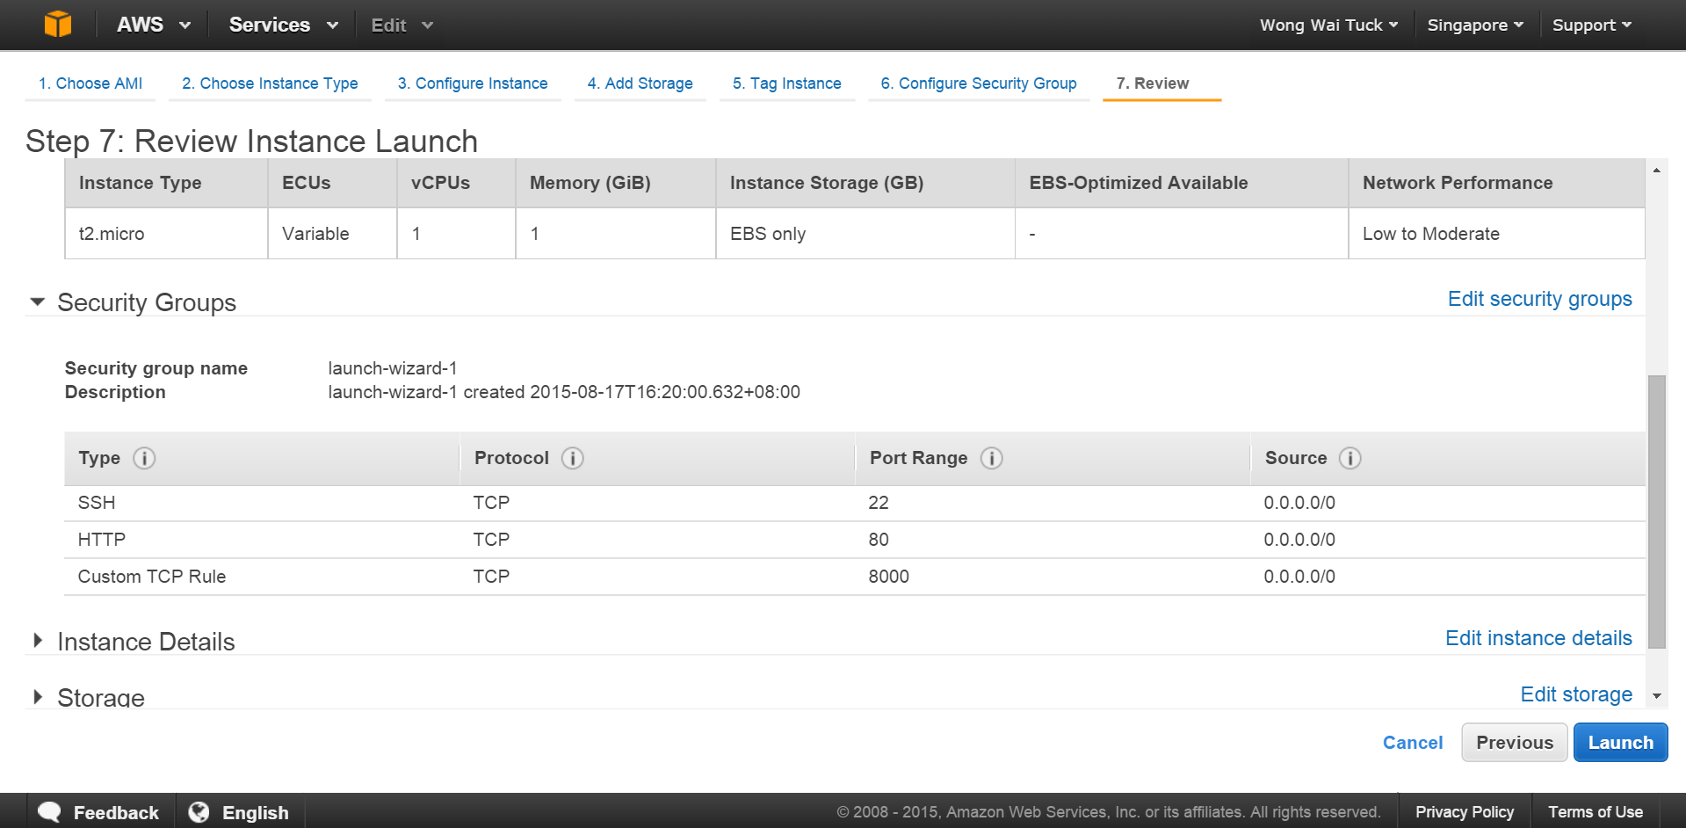
9. Login to your EC2 instance, following the instructions on the screen.
10. Type the following command without quotes to install docker: “sudo yum install docker”
11. Once docker is installed, type the following commands to launch the tmpnb server on the url of the given ec2 instance (on port 8000)!

export TOKEN=$( head -c 30 /dev/urandom | xxd -p )

docker run --net=host -d -e CONFIGPROXY_AUTH_TOKEN=$TOKEN --name=proxy   
jupyter/configurable-http-proxy --default-target <http://127.0.0.1:9999>

docker pull waituck/custom_nb

docker run --net=host -d -e CONFIGPROXY_AUTH_TOKEN=$TOKEN \

-v /var/run/docker.sock:/docker.sock \

jupyter/tmpnb python orchestrate.py --image='waituck/custom_nb' --pool_size=65 --command="ipython notebook --NotebookApp.base_url={base_path} --ip=0.0.0.0 --port {port}"

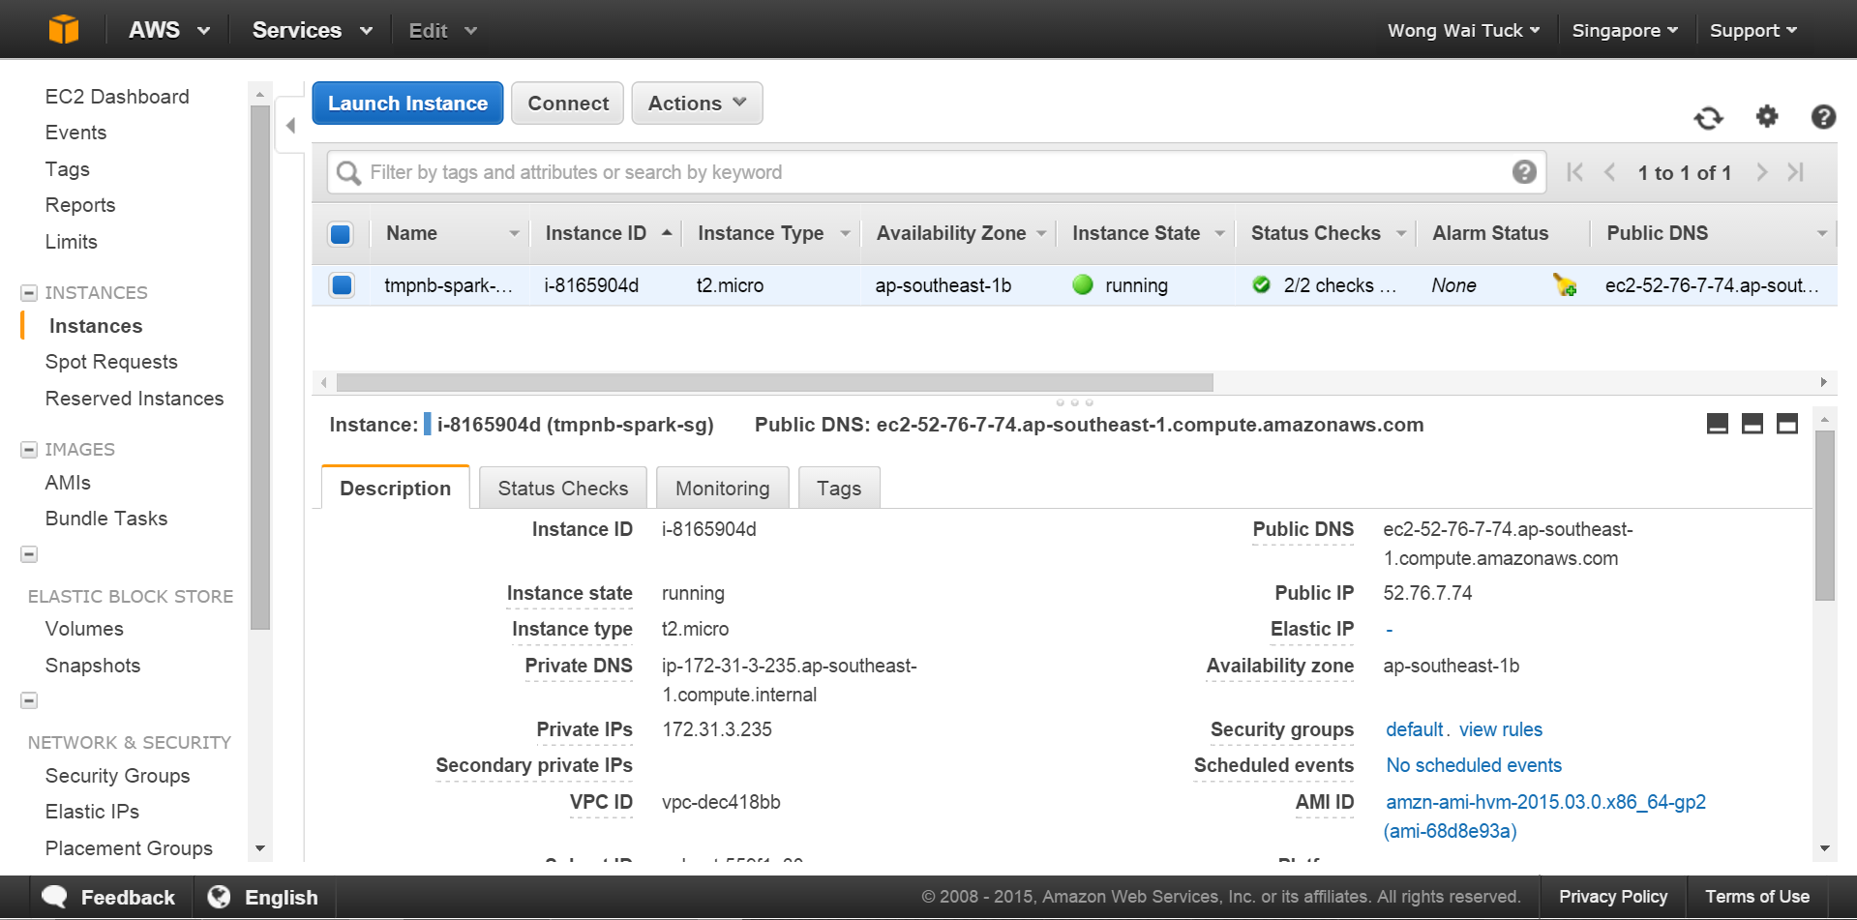

Access the final tmpnb server with the following url:

http://<Public IP>:8000

*NOTE: the mem_limit of teach docker container in the tmpnb server may be modified.

Refer to <https://github.com/jupyter/tmpnb> for the full list of command line options.